**Handa’s surprise: Eileen Browne Walker Books 1995**

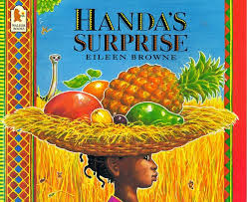

1 Handa put six delicious fruits in a basket for her friend Ayeko. There was a banana, an apple, an orange, a pineapple and an avocado pear.

2 She put the basket on her head

3 She walked along the road

4 ‘I think she likes bananas best’ she said

5 Suddenly the monkey took the banana! Handa didn’t see!

6 ‘I think she likes apples best’ she said

7 Suddenly the ostrich took the apple! Handa didn’t see.

8 ‘I think she likes oranges best ’ she said

9 Suddenly the zebra took the orange! Handa didn’t see

10 ‘I think she likes mangoes best’ she said

11 Suddenly the elephant took the mango. Handa didn’t see.

12 ‘I think she likes pineapples best’ she said

13 Suddenly the giraffe took the pineapple. Handa didn’t see.

14 ‘I think she likes avocadoes best’ she said

15 Suddenly the antelope took the avocado. Handa didn’t see

16 Suddenly the goats hit the tree. Handa didn’t see.

17 ‘’Hello Akeyo’’ said Handa. ‘I’ve got a surprise for you’’

18 ‘’Oh Tangerines!’’ said Akeyo ‘’I like tangerines best!’

19 Who was surprised? Which fruit do you like best?

al and linguistic-verbal students.